
THE CHINESE UNIVERSITY

OF HONG KONG (SHENZHEN)

School of Science and Engineering

Tutorial - 9

Fundamental of Artificial Intelligence CSC3180

- Answer the following questions:

- What is difference between clustering and classification？(unsupervised and supervised)
- What is the advantage and disadvantage of the k-nearest neighbors algorithm?
- What is the influence of the value of K in k-nearest neighbors algorithm? (L10: P10-12)
- What is the difference between the k-nearest neighbor and Support Vector Machine? (no learning and learning)
- What is sparse? How about its advantages?

- There are three categories and in each category there are three points, shown as follows. Give two point x = [0, 0, 4, 2] and y = [-1, 4, 1, 5], please judge these two points belong to which class. (Euclidean Distance)(K=1)
a₁ = [1, 0, 3, 1]; a₂ = [1, 2, 5, 0]; a₃ = [0, 1, 3, 1]
b₁ = [5, -1, 3, 3]; b₂ = [4, 0, 5, 5]; b₃ = [6, 1, 4, 3]
c₁ = [-1, 4, 1, 3]; c₂ = [0, 3, 1, 4]; c₃ = [-1, 3, 2, 3]

- Assume that in a 2-D space, there are two categories, A and B. For A category, there are three training points (red). For B category, there are four training points (blue)
- According to KNN algorithm, how many classification planes among these two categories?
- Please draw classification planes in the picture.
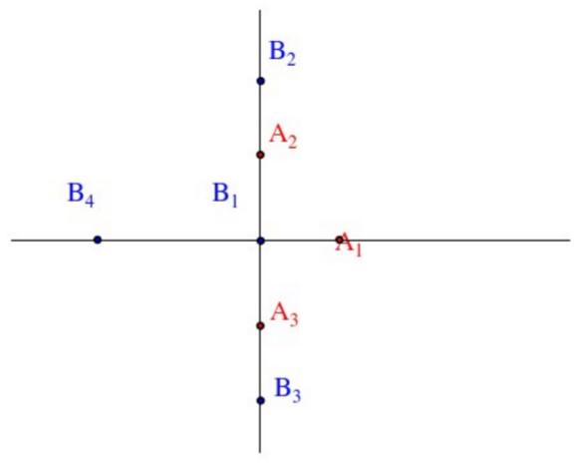

- Please describe the main steps of Sparse Representation Classification.

- Using an example of face recognition, please describe how Sparse Representation Classification works.

